Coming of Age: Margaret Mead

* Beginning on the island of American Samoa.

1925 – Psychological view of Samoan Adolescence

Mom was a Sociologist and worked with Italian immigrants.

Barnard Graduation Ceremony – Meads Alma Mater. Doesn’t seem strange when rites are part of our own society.

Dr. Luther Cressman – l^{st} husband

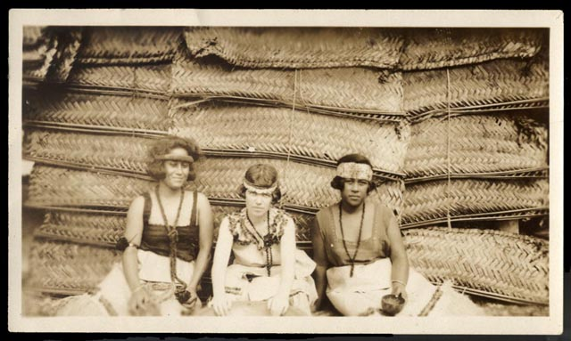
Worked with Franz Boas and Ruth Benedict

Nature /Nurture debate

- Specifically Adolescence –
Local girls asked about sex before marriage

Mead discussing her time there – Food, Clothes

* Coming of Age in Samoa written for the public-at- large
Did she really get Samoan life and language?

1928 – Married Reo Fortune – Little contact with colonials
Manus Islands – Pere Village – interested in the accumulation of wealth

Famous book: 1930
Growing up in New Guinea

Adults: Child-like mentality then what of the children?

First 6 months in Manus
- Watched them drawing
- Representations of real things – boats, beaches, etc.
- 35K drawings and pictures

First discussion of giving back to her
Population –
Self-reflexive

She would return to Pere over and over after World War II

1931 – New Guinea – Began work on gender roles
- Mundugumor
- Arapesh
- Chambri

Met Gregory Bateson while still married to Fortune.

Impact of Anthros on the people they studied – “We were a continuous circus.”

3rd Book: 1925
Sex and Temperament

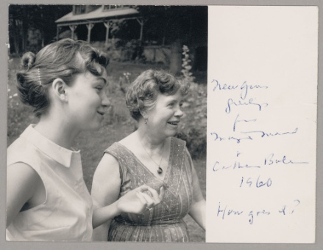
1936 – married Bateson on the way to Bali
Photographic essay linked by works
Most intensively documented with still photos ever done

Early film- Trance and Dance in Bali

- Behaviors of mothers to their babies.

Mary Katherine Bateson – 1939 – daughter

*Breast fed for a long time
Used ideas from “primitive society”
Dr. Benjamin Spock
A completely documented life

World War II – recruited by U.S. War Department to go to England to work out why there was a clash between U. S. soldiers and U.K. women.

U.S. women had the responsibility to say stop.
U.K. stopping was the man’s worry

After war – divorced Bateson.

1957 Writing about the changes she observed since early 1930’s

Mead – Back to Manus Island

Pere Village was moved from the Island Manus to PNG proper.

The people of Pere speak of Mead with a fondness like family members.

Redbook – columns Beginning in 1960.

1975 – Last time she checked in at Pere.

Margaret Mead died in 1978 of cancer. She was 76.

